SIMATS ENGINEERING (SAVEETHA SCHOOL OF ENGINEERING)
Department of Artificial Intelligence and Data Science
ASSESSMENT TOOL 1 – APPLICATION BASED QUESTIONS

Course Code: | DSA03 | Course Title: | Natural Language Processing
CO Assessed: | CO1 – Imitation (L1) | Assessment: | Assessment Tool 1 – Application Based Questions
Weightage: | 40% of CIA
CO1 Statement: | Analyse NLP models, regular expression patterns, finite state automata, morphological processing techniques and to interpret language processing. (BL-3)
Student Name: | A. Vikranth Reddy | Reg. No.: | 192424193
Section / Batch: | 2024 | Date: | 13/07/2026

Code of Conduct
I __________________________ (Name / Reg No) certify that this submission is my original work and that I have adhered to the guidelines specified for this assessment. I understand that any violation of academic integrity rules will result in disciplinary action.
Signature of the Student: _________________________

Instructions
- Develop a modular and efficient Python program that satisfies all the functional requirements specified in the problem statement.
- Demonstrate the correctness of the implementation using suitable test cases and justify the output obtained.
- Follow good programming practices, including meaningful variable names, proper code indentation, comments, and error handling wherever applicable.
- Duration: 30 minutes.

Section / Topic | Focus | Q Nos
Information Extraction | Regex-Based Information Extraction | 1
Pattern Matching | Regex Pattern Matching | 2
Regular Expression Patterns | Regex-Based Input Validation | 3

Annexure A – Application Based Questions

Section 1: Regular Expressions – Resume Information Extraction
- A multinational recruitment company receives thousands of resumes every day in text format. The HR department requires an automated system to extract candidate information for shortlisting.

Design and implement a Python-based resume information extraction system using Regular Expressions that performs the following tasks:

Extract the candidate's name.
Identify email addresses.
Extract mobile numbers.
Detect technical skills (Python, Java, SQL, Machine Learning, NLP).
Extract years of experience.
Generate a structured summary of the candidate's profile.
Display candidates who satisfy the minimum eligibility criteria (minimum 2 years of experience and Python skill).
Aim

To develop a Python program that automatically extracts important candidate details from a resume using Regular Expressions (Regex) and identifies eligible candidates for recruitment.

Technical Explanation

The Resume Information Extraction System is developed using Python and the built-in re (Regular Expression) module. Regular Expressions are pattern-matching techniques used to search, extract, and validate text efficiently.
The program scans the resume text and identifies:
- Candidate Name
- Email Address
- Mobile Number
- Technical Skills (Python, Java, SQL, Machine Learning, NLP)
- Years of Experience
Different Regex functions are used:
- re.search() – Finds the first occurrence of a pattern.
- re.findall() – Extracts all matching values.
- re.IGNORECASE – Makes the search case-insensitive.
After extracting the details, the program generates a structured candidate summary. Finally, it checks the eligibility criteria by verifying whether the candidate has at least 2 years of experience and possesses Python skills. If both conditions are satisfied, the candidate is shortlisted.
Techniques Used
- Python Programming
- Regular Expressions (Regex)
- Pattern Matching
- Information Extraction
- Conditional Statements (if-else)
- List Operations
Test Case
Input
Name: Rahul Sharma
Email: rahul@gmail.com
Mobile: 9876543210
Skills: Python, SQL, NLP
Experience: 3 years
Output
Eligible for Shortlisting

Code:
import re

resume = """
Name: Rahul Sharma
Email: rahul@gmail.com
Mobile: 9876543210
Skills: Python, SQL, Machine Learning, NLP
Experience: 3 years
"""

# Extract Name
name = re.search(r"Name:\s*(.*)", resume)
print("Candidate Name:", name.group(1))

# Extract Email
emails = re.findall(r"[a-zA-Z0-9._%+-]+@[a-zA-Z0-9.-]+\.[a-zA-Z]{2,}", resume)
print("Email:", emails)

# Extract Mobile Number
mobile = re.findall(r"\b\d{10}\b", resume)
print("Mobile:", mobile)

# Detect Skills
skills = ["Python", "Java", "SQL", "Machine Learning", "NLP"]
found_skills = []

for skill in skills:
if re.search(skill, resume, re.IGNORECASE):
found_skills.append(skill)

print("Skills:", found_skills)

# Extract Experience
experience = re.search(r"(\d+)\s+years", resume)
years = int(experience.group(1))
print("Experience:", years, "Years")

# Structured Summary
print("\n------ Candidate Summary ------")
print("Name:", name.group(1))
print("Email:", emails[0])
print("Mobile:", mobile[0])
print("Skills:", ", ".join(found_skills))
print("Experience:", years, "Years")

# Eligibility
if years >= 2 and "Python" in found_skills:
print("Eligible for Shortlisting")
else:
print("Not Eligible")

Output:
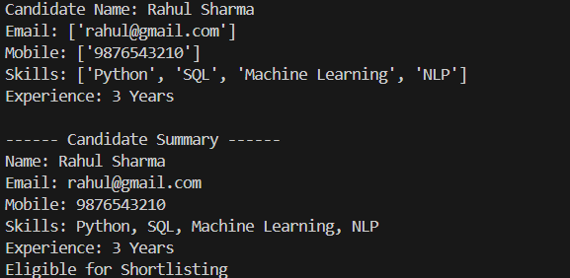

Section 2: Regular Expressions – Product Search System
- An e-commerce company plans to enhance its product search engine to improve customer experience through flexible keyword matching.

Design and implement a Python-based product search system using Regular Expressions that performs the following tasks:

Search products using an exact keyword.
Perform prefix-based searches.
Perform suffix-based searches.
Search using partial keywords.
Perform case-insensitive searches.
Display all matching product names.
Generate a report showing the total number of matching products for each search.
Aim

To develop a product search application using Regular Expressions that performs different types of keyword searches.
Technical Explanation

The Product Search System is implemented in Python using the re module. It allows users to search product names using various search techniques supported by Regular Expressions.
The program performs:
- Exact Keyword Search
- Prefix Search
- Suffix Search
- Partial Keyword Search
- Case-Insensitive Search
Regex functions used include:
- re.fullmatch() – Matches the complete product name.
- re.match() – Matches the beginning (prefix).
- re.search() – Searches for a keyword anywhere in the string.
- re.IGNORECASE – Ignores uppercase/lowercase differences.
Finally, the program displays all matching products and generates a report showing the total number of matches for each search type.

Techniques Used

- Regular Expressions
- Pattern Matching
- String Searching
- Python Lists
- Looping
- Case-Insensitive Search
Test Case
Input
Phone
Output
Exact Match : Phone
Prefix Match : Phone, Phone Case
Suffix Match : Phone, Smart Phone
Partial Match : Phone, Phone Case, Smart Phone
Code:
import re
products = [
"Laptop",
"Laptop Bag",
"Laptop Stand",
"Mouse",
"Keyboard",
"Phone",
"Phone Case",
"Smart Phone",
"Wireless Mouse"
]

# Search keyword
keyword = input("Enter Search Keyword: ")

# Exact Search
exact = [p for p in products if re.fullmatch(keyword, p, re.IGNORECASE)]

# Prefix Search
prefix = [p for p in products if re.match(keyword, p, re.IGNORECASE)]

# Suffix Search
suffix = [p for p in products if re.search(keyword + "$", p, re.IGNORECASE)]

# Partial Search
partial = [p for p in products if re.search(keyword, p, re.IGNORECASE)]

print("\nExact Match:", exact)
print("Prefix Match:", prefix)
print("Suffix Match:", suffix)
print("Partial Match:", partial)

print("\n----- Report -----")
print("Exact Matches:", len(exact))
print("Prefix Matches:", len(prefix))
print("Suffix Matches:", len(suffix))
print("Partial Matches:", len(partial))
Output:
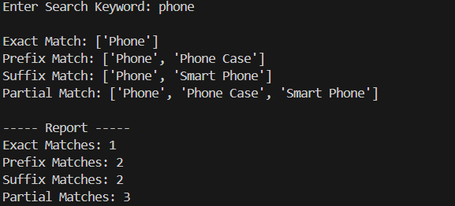

Section 3: Regular Expressions – University Registration System
A university is developing an automated online registration portal to verify student information before course enrollment.

Design and implement a Python-based validation system using Regular Expressions that performs the following tasks:

Validate the student register number.
Validate the institutional email address.
Validate the course code.
Validate the semester information.
Validate the student's mobile number.
Display appropriate validation messages for each field.
Generate a final registration status report indicating whether the registration is successful.
Aim

To develop a validation system that verifies student registration details using Regular Expressions before course registration.
Technical Explanation
The University Registration Validation System uses Python and the re module to validate user inputs according to predefined patterns.
The program validates:
- Register Number
- Institutional Email Address
- Course Code
- Semester
- Mobile Number
Regex patterns ensure that:
- Register Number contains only digits with the required length.
- Email belongs to the institution domain (e.g., @saveetha.com).
- Course Code follows the required format.
- Semester is between 1 and 8.
- Mobile Number contains exactly 10 digits.
Each field is validated individually, and appropriate validation messages are displayed. If all validations are successful, the registration is approved; otherwise, it is rejected.

Techniques Used
- Input Validation
- Regular Expressions
- Pattern Matching
- Conditional Statements
- Boolean Logic

Test Case
Input
Register Number : 192424193001
Email : student@saveetha.com
Course Code : DSA03
Semester : 5
Mobile : 9876543210
Output
Register Number : Valid
Email : Valid
Course Code : Valid
Semester : Valid
Mobile : Valid

Registration Successful

Code:
import re

reg = input("Enter Register Number: ")
email = input("Enter College Email: ")
course = input("Enter Course Code: ")
semester = input("Enter Semester: ")
mobile = input("Enter Mobile Number: ")

# Validation
reg_valid = re.fullmatch(r"\d{12}", reg)

email_valid = re.fullmatch(r"[a-zA-Z0-9._%+-]+@saveetha\.com", email)

course_valid = re.fullmatch(r"[A-Z]{3}\d{2}", course)

semester_valid = re.fullmatch(r"[1-8]", semester)

mobile_valid = re.fullmatch(r"\d{10}", mobile)

print("\nValidation Results")

if reg_valid:
print("Register Number: Valid")
else:
print("Register Number: Invalid")

if email_valid:
print("Email: Valid")
else:
print("Email: Invalid")

if course_valid:
print("Course Code: Valid")
else:
print("Course Code: Invalid")

if semester_valid:
print("Semester: Valid")
else:
print("Semester: Invalid")

if mobile_valid:
print("Mobile Number: Valid")
else:
print("Mobile Number: Invalid")

# Final Report
if reg_valid and email_valid and course_valid and semester_valid and mobile_valid:
print("\nRegistration Successful")
else:
print("\nRegistration Failed")

Output:
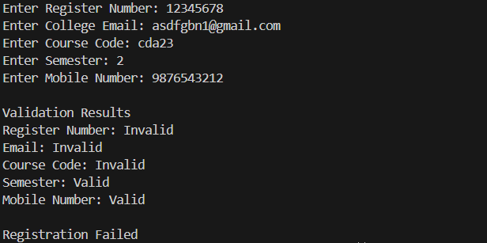

Rubrics for Calculation
Criteria | Weightage | Level 4 – Exemplary | Level 3 – Proficient | Level 2 – Developing | Level 1 – Beginning
Understanding of Problem Context | 20 | Clearly understands the problem and accurately identifies all requirements | Good understanding with minor gaps | Basic understanding; some requirements unclear | Poor understanding or misinterpretation of the problem
Application of Concepts | 30 | Accurately applies appropriate concepts to solve complex problems | Applies relevant concepts correctly with minor errors | Applies basic concepts with limited accuracy | Fails to apply appropriate concepts
Problem-Solving Approach | 20 | Logical, well-structured, and efficient approach | Mostly logical approach with minor gaps | Basic approach with some inconsistencies | Illogical or unclear approach
Accuracy of Solution | 20 | Completely correct solution with proper justification | Mostly correct with minor errors | Partially correct solution | Incorrect or incomplete solution
Clarity | 10 | Clear, well-organized, and properly explained solution | Understandable with minor clarity issues | Limited clarity and explanation | Poorly presented and difficult to understand

Q. No. / Criteria | Understanding of Problem Context | Application of Concepts | Problem-Solving Approach | Accuracy of Solution | Clarity | Sub. Total | Total %
1
2
3

Faculty In-charge | Course Coordinator | Program Director
Signature: _______________ | Signature: _______________ | Signature: _______________
Date: ___________________ | Date: ___________________ | Date: ___________________

